**Team BAY**

**Members: John Herbert Yncierto, Dan Blair Bapilar, John Lawrence Alovera**

**Overview:**

In many households, farms, and small industries, managing water usage efficiently remains a challenge due to the absence of real-time monitoring systems. People often rely on manual checking, which is inaccurate, time-consuming, and prone to overflows or pump dry-run damage. AquaAligned is a real-time water monitoring solution designed to solve this issue by using an ultrasonic sensor to measure water levels and a temperature sensor to track tank conditions. These sensors connect to an ESP8266 NodeMCU Wi-Fi module, which transmits data to a web-based dashboard. The application displays the current water level, temperature, drainage rate, estimated daily/monthly usage, and a graph showing weekly consumption trends. AquaAligned is built for individuals and small organizations seeking to monitor water usage more precisely, reduce waste, and make smarter decisions about their water resources.

**Solving the Problem:**

Many users, especially in rural households and small agricultural setups, face challenges in monitoring water tank levels manually, often leading to water waste, equipment failure, or inconsistent usage tracking. AquaAligned addresses these issues by creating a system that offers real-time monitoring, helping users detect critical water levels, track drainage, and estimate consumption trends. The system is designed with accessibility and ease-of-use in mind, ensuring that even non-technical users can benefit from its features. To ensure its effectiveness and relevance, feedback will be gathered through testing, and the collected data will help refine the features of the application.

**The Application:**

* **Application name:** AquaAligned – Automatic Water Level Monitoring System
* **What it is:**

AquaAligned is a real-time water level monitoring web application designed to assist users in tracking and managing their water usage more effectively. The system uses sensors connected to an ESP8266 NodeMCU to collect and transmit live water level and temperature data to a desktop-accessible dashboard. The application provides smart features that help users visualize tank data, predict usage patterns, and respond to alerts, offering a practical solution to traditional water management problems.

* **Features:**

The team will incorporate the following features into the AquaAligned system:

* + **Real-time Tank Visualization:**  
     Displays the current water level using a graphical tank that fills based on sensor data. Includes percentage and volume indicators.
  + **Temperature Monitoring:**  
     Shows real-time water temperature using data from the DS18B20 sensor.
  + **Drainage Rate Estimation:**  
     Calculates how fast the tank is draining based on recent level changes.
  + **Daily and Monthly Usage Estimates:**  
     Predicts how much water is being consumed based on historical trends.
  + **Weekly Usage Graph:**  
     Displays a line graph of water usage over the past seven days.
  + **Status Alerts:**  
     Provides notifications for low water, full tank, or irregular activity.
  + **Threshold Configuration:**  
     Allows users to set custom alert levels (e.g., low = 20%, full = 95%).
  + **Sensor and System Health Status:**  
     Displays last update time, connection status, and sensor activity.
* **Questions about the Application:**
  + Who are the potential users?

The target users include households, small farms, and institutions that store water in tanks and want to monitor and manage their usage effectively. The design will prioritize accessibility and clarity for users with varying levels of technical experience.

* + What tasks do they seek to perform?

Users want to monitor tank levels remotely, receive alerts about critical water levels, understand consumption patterns, and optimize water usage to avoid waste or damage to pumps.

* + What functionality should any system provide to these users?

AquaAligned should provide real-time readings, intuitive graphs, historical usage tracking, status alerts, and configurable settings—all accessible from a simple desktop web interface.

* + What constraints will be placed on your eventual design?

The system depends on Wi-Fi connectivity for data transfer, which may limit use in areas without stable internet. Users with visual impairments or color blindness may require more accessible UI options (e.g., icons or labels in addition to color). Additionally, the current version is designed for desktop only and does not support mobile use or automatic pump control, though these may be considered in future updates.

* + What criteria should be used to judge if your design is a success or not?
    - The project will be considered successful if:
* Users can easily understand and operate the web interface.
* Water level and temperature data are displayed accurately and in real time.
* Alerts and estimations help users reduce water waste or equipment issues.
* The application provides clear insight into water usage trends and behavior.
* **Approach:**

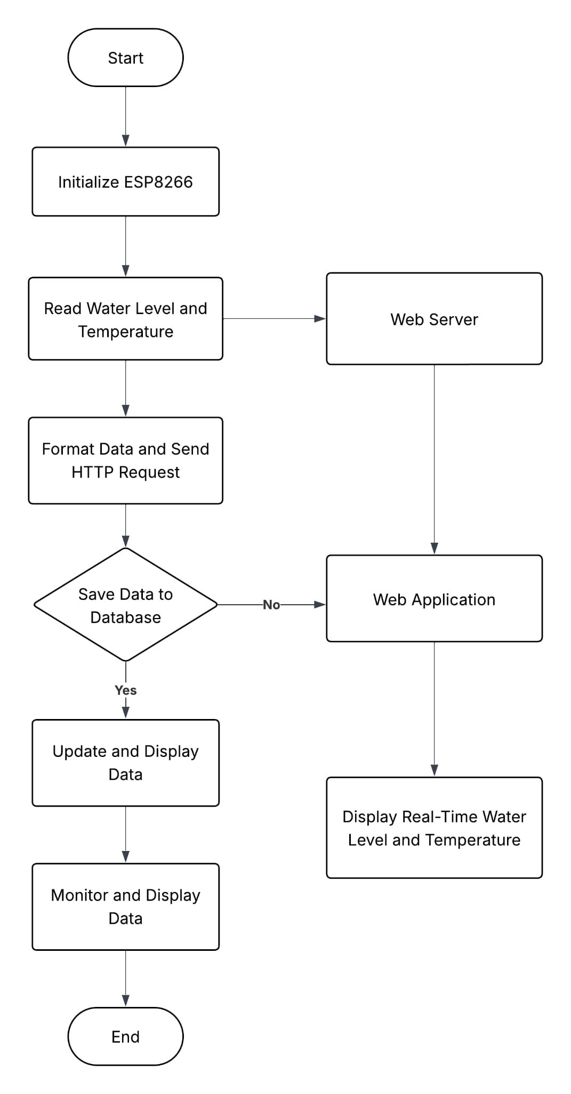

**Figure 1: Flowchart**